Resources:

<http://conqueringthecommandline.com/book/basics> (Command Line Functions)

<https://www.learnenough.com/command-line-tutorial> (Command Line Basics)

<https://files.fosswire.com/2007/08/fwunixref.pdf> (Cheat Sheet)

<https://flashcards.github.io/command_line/introduction.html> (Flash Cards)

<https://www.youtube.com/playlist?list=PLT98CRl2KxKHaKA9-4_I38sLzK134p4GJ> (Linux YT)

<https://git-scm.com/book/en/v2/Getting-Started-Getting-Help> (Git Documentation)

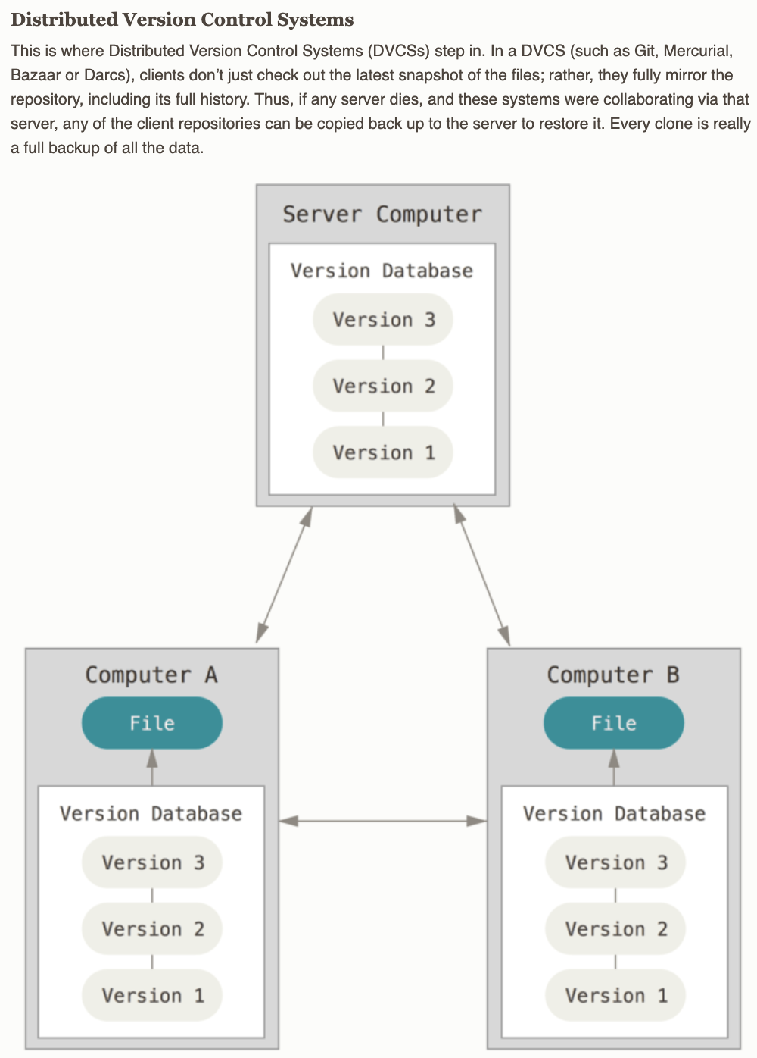

**FreeCodeCamp - HTML5**

This creates a paragraph with a hyperlink in the middle, href=”#” Makes it a deadlink(placeholder)

<p>

Here's a <a target="_blank" href="https://www.freecodecamp.org"> link to www.freecodecamp.org</a> for you to follow.

</p>

OUTPUT: Here's a [link to www.freecodecamp.org](https://www.freecodecamp.org/) for you to follow.

This adds an image to the webpage, alt is used if the webpage is loaded without css?

<img src="https://www.bit.ly/fcc-relaxing-cat" alt="A cute orange cat lying on its back.">

Images can be nested in href to create a hyperlinked image

<a href="#"><img src="https://www.bit.ly/fcc-running-cats" alt="Three kittens running towards the camera."></a>

This creates bullet-points/unordered lists

<ul>

<li>milk</li>

<li>cheese</li>

</ul>

Creates a list that is enumerated. I.e 1. 2. 3. 4. (Ordered List)

<ol>

<li>Garfield</li>

<li>Sylvester</li>

</ol>

Getting input from user - Blank box//Placeholder text can be placed

<input type="text" placeholder="this is placeholder text"

>

The input above can be nested in this so that the page is redirected after a form is submitted.

<form action="/url-where-you-want-to-submit-form-data">

<input>

</form>

Placed after the input in the form block to add a button that submits form

<button type="submit">Submit Form</button>

Having the required keyword makes input mandatory

<input type="text" required placeholder="cat photo URL">

This creates two multiple choice inputs that clear if the other is chosen.

<label for="indoor">

<input id="indoor" type ="radio" name ="indoor-outdoor">Indoor

</label>

<label for="outdoor">

<input id="outdoor" type="radio" name="indoor-outdoor">Outdoor

</label>

This adds a checkbox...Adding the word ‘checked’ anywhere makes the box defaultly checked

<label for="loving"><input id="loving" type="checkbox" name="personality"> Loving</label>

Value makes sure that when someone submits a checkbox answer, we can use it to see what they selected.

<label for="indoor">

<input id="indoor" value="indoor" type="radio" name="indoor-outdoor">Indoor

</label>

Division element is commonly used to wrap things up into a block for CSS styling purposes

<div>

</div>

Doctype and declaring it - Is required and all code is written inside the two html tags

<!DOCTYPE html>

<html>

<CODE GOES HERE>

</html>

CSS Notes

Changes the colour to red

<h2 style="color: red;">CatPhotoApp</h2>

Style tags create a block - This block makes all h2 tags red

<style>

h2 {

color: red;

}

</style>

This creates a class called “blue-text” and then can be called by <h2 class=”blue-text>

<style>

.blue-text {

color: blue;

}

</style>

Changes font size - placed inside the <style></style>

h1 {

font-size: 30px;

}

Calls upon the google font library

<link href="https://fonts.googleapis.com/css?family=Lobster" rel="stylesheet" type="text/css">

Fonts can then be called upon with this in the CSS.

font-family: FAMILY_NAME, GENERIC_NAME;

If the called upon font (aka FAMILY_NAME) isn’t available, then a generic one can be entered so that it automatically downgrades to it. E.g monospace, sans-serif

Create class that controls image width

<style>

.smaller-image {

width: 100px;

}

</style>

This is the usage of the class, it is used after the img keyword

<a href="#" ><img class="smaller-image" src="ht

Creating a class for borer

<style>

.thin-red-border {

border-color: red;

border-width: 5px;

border-style: solid;

Border-radius: 10px; <!-- This is also useful to make the border rounded, %’s work -->

}

</style>

Multiple classes can be used it just needs to be separated by a space

<img class="class1 class2">